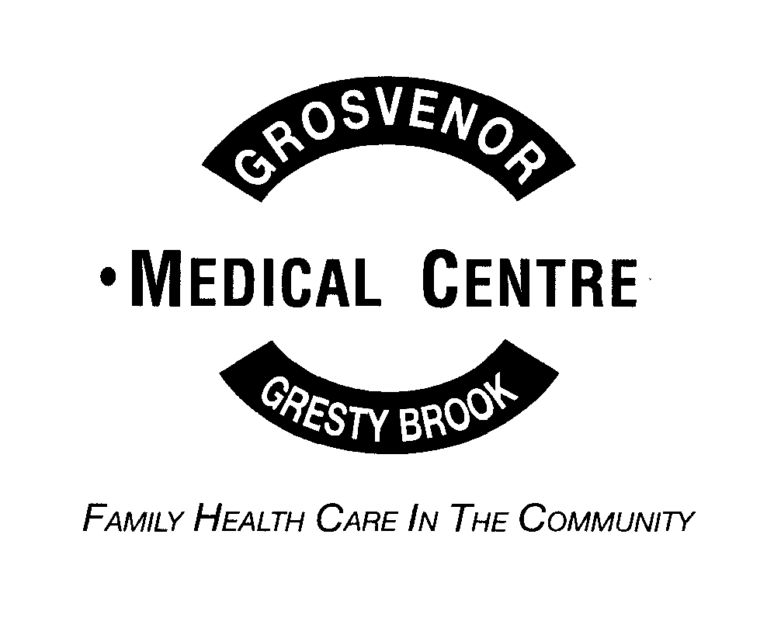

GROSVENOR MEDICAL CENTRE
AND GRESTY BROOK SURGERY
PRACTICE LEAFLET

The Practice has been serving the population of Crewe for over 100 years.

The aim of the practice is to provide a comprehensive range of primary health services and access to appropriate secondary (hospital based) services. The practice is committed to developing both new and improving existing services and to training staff to a high level.

Many services are run from the Practice. Alongside our GP and Nursing services, we offer Phlebotomy, Dietician, Musculoskeletal Practitioners, a Mental Health Nurse and Social Prescribing services.

THE DOCTORS

DR. NICOLA SIMPKIN
DR. VICTOR OGBONNAYA
DR. KELVIN ERDEM
DR. VICTORIA SADLER
DR. CHRISTOPHER FISHER

ASSOCIATE DOCTORS

DR HELEN FLEMING
DR CHUKWUDI ODIKE
DR NEHA TYAGI
DR MICHAEL DIM

GP REGISTRARS

We are a training practice so we also have GP Registrars and medical students working at the practice.

ADVANCED CLINICAL PRACTITIONERS

EWAN ARMITAGE (PARAMEDIC)
MARK BOYLE (PARAMEDIC)
LORRAINE HUGHES (ACP)

NURSING STAFF

SISTER C CAMPBELL
SISTER H FISHER
SISTER T JENKINS
SISTER E MCCLURE
NURSE R WRIGHT
NURSE S DOCTROVE

YOUR PRACTICE LEAFLET

Please read this leaflet carefully and keep it somewhere safe and accessible. It will inform you of the services available.

THE PRACTICE AREA COVERS

Crewe, Coppenhall, Warmingham, Haslington, Weston, Hough, Wybunbury, Shavington, Willaston, and Wistaston. For our boundary, please see here -

https://grosvenormedicalcentre.org.uk/services/new-patients/

THE PRACTICE LIST SIZE

Our practice population (as at November 2025) is 15,360 patients.

GROSVENOR MEDICAL CENTRE

This is the main surgery, serving central Crewe and Coppenhall. Patients’ can contact the surgery from 8.00am until 6.30pm Monday to Friday. The practice website is open from 8.00am to 6.30pm Monday to Friday for non-urgent requests and queries. The website address is below.

There is a small car park and a pharmacy next to the surgery.

URGENT APPOINTMENTS
Telephone: 01270 256348

ROUTINE APPOINTMENTS
To request a routine appointment, please visit our website at www.grosvenormedicalcentre.org.uk

If you cannot do so, please call 01270 256348 and a member of the Reception Team will submit a request to the website for you.

VISITS & ENQUIRIES
Telephone: 01270 256340

DISABLED ACCESS

The surgery has a disabled parking place, disabled access and toilets available.

GRESTY BROOK MEDICAL CENTRE

This is the Branch surgery at the south end of Crewe. The surgery is open from 8.00am until 6.00pm Monday to Thursday and closes at 5pm on Friday. Gresty Brook is also open on Saturday mornings 8.00am until 11.30am for prebooked appointments.

There is a small car park and a pharmacy next to the surgery.

APPOINTMENTS AND QUERIES:
Telephone: 01270 650012

There are a limited number of appointments to give away on the day at Gresty Brook, so patients may be asked to attend the Grosvenor Medical Centre.

ROUTINE APPOINTMENTS
To request a routine appointment, please visit our website at www.grosvenormedicalcentre.org.uk

If you cannot do so, please call 01270 650012 and a member of the Reception Team will submit a request to the website for you

DISABLED ACCESS

The surgery has a disabled parking place, disabled access and toilets available.

HOW TO SEE THE DOCTOR OR PRACTICE NURSE

Routine doctors and nurses appointments can be requested on our website at www.grosvenormedicalcentre.org.uk

We encourage our patients to use this method rather than calling the practice. The website is open between 8.00am and 6.30pm Monday to Friday (except Bank Holidays or when capacity has been reached). You will be contacted by a member of the team to arrange your consultation. If you are not online, visit the practice or call us.

Urgent appointments need to be requested by telephone or by attending the Reception desk. All urgent requests will be dealt with as quickly as possible but, you may not be able to see the doctor you would prefer. Please use urgent appointments considerately.

Where appropriate it may be suggested that one of our practice Nurses or ACPs rings you to give advice.

You can also make some appointments (such as immunisation or smear tests) and order repeat prescriptions using online services such as the NHS App, myGP App or Patient Access. Please ask at Reception for more information.

IF YOU ARE UNABLE TO KEEP YOUR APPOINTMENT PLEASE LET US KNOW AS SOON AS POSSIBLE SO IT CAN BE OFFERED TO ANOTHER PATIENT. If you have a mobile number, you will in most cases have been sent a reminder text. This text can be used to cancel your appointment. Please be aware repeated non-attendance of appointments can lead to removal from the Practice list.

SERVICES PROVIDED

HOME VISITS
Telephone:
Grosvenor on 01270 256340 or Gresty Brook on 01270 650012

Home visits are only offered to those who are unable to attend the surgery for an appointment because of illness or are housebound. Patients should ring the above numbers before 10.30am for a routine visit. After this time the doctors will instruct the Reception Team to ask for more information to enable the Doctor to assess the urgency of the call. Afternoon visits are for medical emergencies that have only just occurred. In other circumstances you may be offered a routine visit the next working day.

TELEPHONE CONSULTATIONS
The practice has arrangements for patients to speak to doctors and nurses on the telephone each day. The Receptionist will take your details and the clinician will then call on the day you booked your appointment between 8.45am and 6.00pm.

NHS 111 SERVICE
The Out of Hours service runs from 6.30pm-8.00am weekdays, at weekends and on bank holidays.

The telephone number is 111 calls to this service are free of charge.

REPEAT PRESCRIPTIONS
Repeat prescriptions can be requested via online services and will be sent electronically to your nominated pharmacy once approved. Paper prescriptions that have a slip for requesting your repeat prescription can be handed in to the surgery.

Your request will take two working days to be processed by the Practice, and please alllow time to be processed by your Pharmacy. Please bear this in mind when your medications are due to be re-ordered. The Practice will not be responsible for late ordering. If you are over ordering an item this may not be issued.

ONLINE SERVICES
You can now request routine GP and Nurse appointments, submit queries and order repeat medication online through our website at www.grosvenormedicalcentre.org.uk.

You can also register to use online services such as NHS App, myGP App and Patient Access to make limited types of appointments, order your repeat prescriptions and see your medical records. To register, please visit the practice with photo identification and ask to register for our online services.

CERVICAL SMEARS
All women, aged 25-65, who have ever been sexually active should have regular smears at five yearly intervals. The National Screening Service recall system sends for women when their smear is due. The Practice only send reminders for ladies who have not attended for their smear. When you receive a reminder you can request an appointment using our website, your own online services or by calling or visiting the Practice.

CHILD IMMUNISATIONS
Immunisations are extremely important in reducing the number of cases of several extremely unpleasant and potentially fatal illnesses. Vaccinations are routinely offered to all children against Diphtheria, Tetanus, Whooping Cough, Polio, Measles, Mumps, Rubella, Meningitis (Hib), Meningitis C, Pneumonia & Rotovirus.

A letter will be sent by the Childhood Immunisation Team to notify you that your child is due an immunisation. You can request these appointments on our website, use online services to book them or call or visit the practice.

The practice will also send you reminders if you do not book these appointments. You must tell us if you prefer not to vaccinate your children, and this needs to be recorded by the Practice Nurses and passed to the Child Health Department.

ADULT IMMUNISATIONS
The practice runs annual influenza vaccination clinics (usually around September/October) for those groups of patients who are over 65 or at risk. We encourage these patients to book and attend as soon as they are called, as once our allocated stock has been used these patients will then have to be vaccinated elsewhere. The practice also offers pneumonia and shingles vaccinations where appropriate.

We also offer travel vaccinations. Please contact the practice to have an initial telephone consultation with a Practice Nurse to discuss travel vaccinations.

OTHER CLINCS AND SERVICES
As well as normal GP/Nurse appointments, the following clinics are available to patients. Please see the Reception Team for further details:

Diabetic Clinics
Asthma Clinics
COPD Clinics
Dietitian
Mental Health Nurse & Social Prescribing
Musculoskeletal Practitioners

THE PRACTICE TEAM

PRACTICE STAFF
We value our staff, who provide an efficient service and aim to allow all our patients to make the best use of the facilities. Please treat them with respect. The Practice operates a strict zero tolerance policy regarding rude, abusive or violent behaviour towards staff or other patients either in person, on the telephone or via online methods. The Practice does not hesitate to remove patients from the list where this policy’s guidelines have been broken.

RECEPTIONISTS
Our team of receptionists is here to help you when telephoning or attending the Practice. The Receptionists are instructed by our Doctors and Nurses to ask you details of the reason for your visit – please answer their questions. Please be patient, as these enquiries will enable them to help you in the most appropriate way.

PRACTICE MANAGER
The Practice Manager has the task of coordinating the administrative and financial side of the practice. If there are any comments on the administrative side of the practice, good or bad, please pass them on in person or by letter. The practice is open to new ideas and would like to encourage patients to bring them forward. The Practice has an in-house complaints procedure which can be found on our website or at Reception.

MEDICAL TRAINING
The practice is a training practice and fully qualified and experienced doctors at the start of their career in general practice are invited to join the practice for a period to gain further experience.

MEDICAL STUDENTS
The Practice teaches Medical Students. You may be asked if you mind a student sitting in on your consultation or spending some time with you to discuss your health.

ADVANCED CLINICAL PRACTITIONERS
Advanced Clinical Practitioners (ACP) are employed by the practice. The ACPs re highly experienced and educated clinicians who are able to assess, investigate, diagnose, and prescribe.

PRACTICE NURSES
Practice Nurses are employed by the Practice. Nursing staff are available for dressings and routine nursing duties at the surgery. They also run specialised Clinics and give vaccinations.

GENERAL PRACTITIONER ASSISTANT
General Practitioner Assistants (GPA) work with the GPs to support clinical and administrative duties.

CLINICAL PHARMACIST & PHARMACY TECHNICIANS
Our pharmacy team work directly with you as part of the GP team to make sure your medicines help you to get better and stay well. You can book in to see our clinical pharmacist for medication reviews and telephone consultations for medication queries.

DIETICIAN
Dieticians provide expert advice about weight reduction and special diets. The Doctor or Nurse will arrange an appointment if appropriate. The Dietician provides individual counselling for many conditions and, if requested, we are willing to arrange group sessions for weight reduction.

MSK PRACTITIONERS
Our musculoskeletal practitioners can help with soft tissue/muscle/joint issues.

WELLBEING TEAM
We have a growing Wellbeing team that is made up of Social Prescribers, Care Co-ordinators and a Mental Health Nurse.

DISTRICT NURSING, MIDWIFERY AND HEALTH VISITORS ARE ALL BASED AT EAGLE BRIDGE HEALTH AND WELLBEING CENTRE, CREWE.

ADMINISTRATIVE MATTERS

NON NHS SERVICES FORMS
Certain services are not available on the NHS and a fee may be payable. These include medical/holiday insurance forms, HGV, PSV licence and elderly drivers examinations, solicitors letters (unless submitting subject access requests), private sick notes, etc. A list of current fees is available at the surgery.

Please help the doctor by filling in the appropriate details before passing to the reception staff i.e. name, address, dates of absence/illness. Please be aware as this is private work and not clinical, it may take several days to complete these forms. We aim to complete within 28 days of receipt.

HOW TO REGISTER WITH THE PRACTICE
You can register with the practice online here - https://www.nhs.uk/service-search/find-a-gp/ Please be aware that if you are new to the UK we may ask you to attend in person to register. Alternatively, you can collect the necessary paperwork from the Practice, which consists of a registration form and a questionnaire. Fill the forms in and pass them back to reception. You can also apply for online services at the same time, but you will need to provide identity documents for this in the form of photographic identity or proof of address. If you do not have this documentation, the Practice may be able to verify your identity using other means.

If you are on regular medication please request an appointment to see our GPs, ANPs or clinical Pharmacist for a medication review.

CHANGE OF PERSONAL DETAILS
Should you change your name/address, or telephone number, please let the reception staff know. If you move outside the practice area it will be necessary for you to find a doctor in your new area.

Please note that a change of address at the surgery does not transfer to any hospitals/other services, so if you are having treatment please ensure you inform these services as well so you do not miss appointments/letters. It is not the Practice’s responsibility to inform anyone else of your change of address.

PATIENT PARTICIPATION GROUP
The practices supports an active Patient Participation Group (PPG). The PPG works with the practice on small Projects, eg, Flu clinic and patient surveys.

PCN
Grosvenor Medical Centre is part of the GHR PCN group, with Hungerford and Rope Green Practices The PCN is working collaboratively on providing services thorough our community.

